
MIZAN–TEPI UNIVERSITY
SCHOOL OF COMPUTING AND INFORMATICS
DEPARTMENT OF INFORMATION TECHNOLOGY

PROJECT TITLE : LIBRARY INFORMATION MANAGEMENT SYSTEM

Group-4

NO GROUP MEMBERS ID NUMBER
1, ADANE DIGA MTUUR/8415/17
2, BELAY TESHOME MTUUR/8606/17
3, BINIYAM BIYADGIE MTUUR/7866/17
4, ETHIOPIA WORKU MTUUR/8567/17
5, HAMDU IDRIS MTUUR/8293/17

Submission Date:04/05/2018 E.C
Submitted To:Mr BIRHANU
TEPI,ETHIOPIA

Acknowledgment
We would like to express our deepest gratitude to our instructor, Mr. , for their invaluable guidance, support, and encouragement throughout the development of this library database design project. Their expertise and insights have been instrumental in shaping our understanding and approach to this project.
We extend our sincere thanks to our classmates and peers for their constructive feedback and collaborative spirit, which have greatly contributed to the success of this project. Their willingness to share knowledge and ideas has been a source of inspiration and motivation.
We are also grateful to the library employees and patrons who provided us with practical insights and real-world scenarios, helping us to design a system that meets the needs of its users effectively. Their input has been crucial in ensuring the relevance and usability of our project.
Lastly, we would like to acknowledge the unwavering support of our families and friends, whose encouragement and understanding have been a constant source of strength throughout this journey.
Thank you all for your contributions and support.

Table of content
Chapter one .............................................................................................................................1 1.IntroductionProject ......................................................................................................................2
  - Background..............................................................................................................................…2 1.2 Statement of Problem............................................................................................................…..5 1.3 Objective........................................................................................................................................6 1.3.1 General objectives.....................................................................................................................6 1.3.2 specific..........................................................................................................................6 1.4Methodology ......................................................................................................................7 Chapter2 DatabaseDesigning ................................................................................................................10
2.1 Database Modeling .................................................……………………………………………………………………11
2.2 Business Rules and Requirements for the Library ManagementSystem .............................................12 2.3 Building Block of the Database ....................................................................................................14
2.4 ER Diagram.....................................................................................................................................17 2.5 Relationships.....................................................................................................................................18 : 2.5 Relational model :Mapping ER Diagram to Relational diagram Model....................……………………… .
2.6 Normalization.................................................................................................................................23 Chapter3........................................................................................................................…………………….34 3.1 Database Implementation........................................................................................................................……………..34 3.2 Whole SQL Command to develop LMS database with some inserted values........................………..35 3.3 Relational diagram.............................................................................................................................39 Reference ...................................................................................................................................................44

CHAPTER ONE
INTRODUCTION
A library is a collection of organized information and resources which is made accessible to a well-defined community for borrowing or reference sake. The collection of the resources and information are provided in digital or physical format in either a building/room or in a virtual space or even both. Library's resources and collections may include newspapers, books, films, prints, maps, CDs, tapes, videotapes, microform, database etc. The main aim of this system is to develop a new programmed system that will conveying ever lasting solution to the manual base operations and to make available a channel through which staff can maintain the record easily and customers can access the information about the library at whatever place they might find themselves. Library Management System allows the user to store the book details and the customer details. The system is strong enough to withstand regressive yearly operations under conditions where the database is maintained and cleared over a certain time of span. The implementation of the system in the organization will considerably reduce data entry, time and also provide readily calculated reports.

1.1 Background
Libraries have long been essential repositories of knowledge, playing a crucial role in education and research. Traditionally, they have managed extensive collections of books, journals, and other resources manually. However, with the growing volume of information and user demand, libraries face significant challenges in maintaining and accessing book records efficiently.
Survey of Technologies
Through improved functionality, reliability, and user satisfaction, the integration of such technologies ensures that the Library database System satisfies the needs modern libraries. The system can turn routine library tasks into a more efficient, automated procedure by utilizing the right tools and techniques. Several technologies that meet the demands for modern libraries must be integrated for a library database system to be successful. Strong database systems are essential for the effective management of library records. Modern Relational Database Management Systems (RDBMS) are among the popular database technologies. These systems define, modify, and query data using SQL (Structured Query Language) and structured data models. The typical programming language for administering and working with relational databases is called SQL (Structured Query Language). It offers strong commands for data creation, updating, and retrieval and high availability, essential for a dynamic environment like library data base system.

Title-based Area
This project belongs to the domain of Library database Systems, aiming to revolutionize the way libraries operate by introducing a modern, centralized digital solution. It focuses on streamlining core functions such as cataloging books, managing member records, tracking borrowing and returns, monitoring overdue items, and automating fine collection. Additionally, it ensures seamless inventory oversight and efficient data handling. By replacing traditional manual processes with an intelligent system, this project aspires to enhance operational efficiency, minimize errors, and elevate the experience for both library customer and employee.

1.2 Statement of problem

Manual book tracking
The library currently relies on a manual system for book tracking, which is time-consuming, prone to errors, and lacks efficiency.
The manual system leads to discrepancies in book availability, inaccurate status updates, and challenges in managing costs and quantities effectively.

Limited Accessibility and User Experience
Users find it cumbersome to locate books, check their availability, or obtain accurate information about costs and status due to the manual system.
Lack of a centralized system affects user experience, resulting in dissatisfaction and reduced efficiency in borrowing or purchasing books.

Data Security and Reliability
Storing book information through manual writing raises concerns about data safety, consistency, and potential loss or damage to records.
Paper-based records are susceptible to damage, loss, or unauthorized alterations, compromising the integrity and security of book information.

Management Challenges

Managing costs, availability, and overall book inventory becomes challenging without a structured, automated system.

Manual systems lead to difficulties in tracking the total number of books available, their costs, and maintaining accurate status record.

Recommended solution
It keeps track of all the information about the books in the library, their cost, status and total number of books available in the Library.
The user will find it easy in this automated system rather than using the manual writing system. The system contains a database where all the information will be stored safely.

Business rules

Borrowing Rules
Define the maximum period a user can borrow a book.
Set limits on the maximum number of books a user can borrow simultaneously.
Overdue Fines: Determine fines and penalties for late returns or overdue books.

Membership Rules
Establish different membership tiers (e.g., student, faculty, premium ) with varying borrowing privileges.
Define the duration of each membership tier and its renewal policies. Determine any restricted access for specific membership categories.

Book Status and Availability
Define statuses like "Available," "Checked Out," "Reserved," or "Lost/Damaged."
Specify procedures for updating availability status upon book check-in, check- out, reservation, or loss.

Inventory Management
Ensure accurate recording of the cost of books, including purchase, replacement, or maintenance costs.
Maintain a real-time count of the total number of books available in the library.

Data Integrity and Security
Implement validation checks to ensure accurate and consistent data entry for book information.
Define user roles, access levels, and authentication protocols to safeguard sensitive data and prevent unauthorized access.

Notification and Communication
Establish a system to notify users about overdue books and fines. Notify users when a reserved book becomes available.

1.3 Objectives of Library Database Design

1.3.1 General Objective
The general objective of this project is to design a comprehensive and efficient Library Database that facilitates the organization, storage, and retrieval of library-related data, ensuring better management of book records, user information, and transactions.
1.3.2 Specific Objectives
- Enhance Performance and Control: The database design aims to:
The database will address modern challenges by ensuring efficient data storage, retrieval, and validation of user and book records, minimizing errors and improving overall system performance.
• Reduce Operational Cost :With the adoption of a digital database design, the need for manual data handling will decrease, reducing labour costs associated with maintaining and updating records.
• Save Time: The database will provide efficient data querying capabilities, allowing librarians to quickly search and retrieve records with minimal effort, ultimately saving valuable time.
• Centralized Information Sharing: The design will support features like an online notice board for the library, enabling librarians to efficiently share updates, workshops, and events with users.
• Automate Book Catalog and Indexing: The system will automate the process of catalog and indexing books, making it easier to add, update, and organize book records in the database.
• Provide Efficient Search and Retrieval: The database will feature powerful search capabilities, enabling users and librarians to quickly find relevant book and user information through well-indexed queries.
• Track Borrowed Books and Overdue Fines: The design will incorporate automated tracking of borrowed books and the calculation of overdue fines, reducing manual tracking and ensuring accurate record-keeping
• Increase Accuracy and Reduce Human Error: By minimizing manual data entry and ensuring well-structured data models, the database design will improve the accuracy of records and reduce human errors in data management.
• Simplify System Operations: The design will ensure that the system is intuitive and easy to operate, requiring minimal training for library staff and providing an overall user-friendly experience.
Scope of the project
When Without a Library management System, managing and maintaining the details of the book is a tedious job for any college. Library management system will store all the details of the books including their category, availability and also maintains the details about the students to whom the books are issued.
The scope of this project is restricted to library management system of universities, colleges, public and private libraries.

Significance of the system

The significance of this project includes:

Efficient Resource Management
- A library database enables systematic cataloging of books, journals, and other resources, making it easier to organize and manage the collection.
- It helps in tracking inventory, identifying misplaced items, and maintaining accurate records of borrowed and available materials.

Enhanced User Experience
- Users can easily search for and locate resources through a digital catalog, saving time and effort.
- Advanced search filters (e.g., by author, title, subject) ensure users find the information they need quickly.

Improved Accessibility
- A library database can be accessed online, allowing users to check availability, reserve books, or read e-books remotely.
- It bridges geographical barriers, especially for academic or public libraries.

Cost and Time Savings
- Automating tasks and reducing paperwork leads to significant cost savings over time.
- Staff can focus on more meaningful activities, such as engaging with users and promoting literacy programs.
1.4 Methodology

The methodology for the Library data base System project encompasses several key components designed to ensure a comprehensive and effective implementation of the database system. This includes data collection techniques, database modeling approaches, and hardware and software requirements.

Data Collection Technique

To understand the specific needs and challenges faced by library staff and patrons, a combination of qualitative and quantitative data collection techniques will be employed:

-Surveys and Questionnaires: Distributed to library users and staff to gather insights on current challenges, desired features, and user experiences with existing systems.

-Interviews: Conducted with library management and staff to obtain detailed feedback on operational processes and the specific requirements for a new system.
We have asked different questions related with library system such as;
- How books are issued?
- What are the requirements that student must fulfill to borrow a book?
- What kind of books can a student borrow?
- Is the manual system comfortable?
- How the manual system works?
- What type of new coming technologies is being used?

-Observation
As students and users, we have observed the library how it manages its day to day task. The librarian simply makes themselves busy of manual papers. The manual system faces so many challenges in maintaining time and queue. As it is a traditional system, we can’t find whatever book we need with respective time. We have seen public libraries: using such manual system. The librarians are also fading up with the library job because of the hard and tiring situation.

- Existing Data Review: Analyzing current records and processes to assess data accuracy and identify the volume and types of information that need to be digitized.

Hardware and Software Requirements
To successfully implement the Library data base System, specific hardware and software requirements must be met:
Hardware Requirements
❖Computer Device name: LAPTOP-61GRR2KH
Processor : Intel(R) Celeron(R) N4120 CPU @ 1.10GHz 1.10 GHz
Installed RAM: 4.00 GB (3.65 GB usable)
❖ Server: A dedicated server or cloud-based solution to host the database and handle user requests.
❖Flash disk: To keep backup of our file.
❖ Network Infrastructure: A reliable network setup to ensure smooth connectivity between the server and user workstations, including routers and switches.
Software Requirements
- Database Management System (DBMS): A DBMS such as SQL will be required to create and manage the database.
- User Interface Software: Development tools to create a user-friendly interface for both library staff and patrons, potentially using web-based technologies for accessibility.
- Operating System: Compatible operating systems (e.g., Windows, Linux) for the server and client machines.
- Backup Solutions: Software for regular data backups to prevent data loss and ensure data recovery in case of system failure.
By following this structured methodology, the Library data base System aims to enhance the efficiency of book records management, ultimately improving service delivery and user satisfaction in library environments.

CHAPTER TWO
Conceptual database design
Conceptual design is the first stage in the database design process. The goal at this stage is to design a database that is independent of database software and physical details. The output of this process is a conceptual data model that describes the main data entities, attributes, relationships, and constraints of
Identifying Entities, Attributes and Relationships
A, ENTITIES: An entity is any object, thing, or concept in the real world that has data stored about it in the database. They are typically things that have attributes, and they can have relationships with other entities.
B, ATTRIBUTES: Attributes are the properties or characteristics. In a relational database, an attribute corresponds to a column in a table. Each attribute holds a specific piece of data about an entity and helps to describe it more fully .
- key points about Attributes
1, Types of Attributes
- Simple : An attribute that cannot be divided further ( e. g , “Age”).
- Composite : An attribute that can be divided into smaller subparts (e. g “Full name “ can be divided in to “first name” and “last_name”).
- Derived :Attributes that can be derived from other attributes .
Example “Age” can be derived from (“Date of birth”).
- Multi-valued: Attributes that can hold multiple values. (e.g “phone numbers” where a customer might have more than one phone number).
2, Types of Data :
- Attributes can hold different types of data, such as text, number, dates, or Boolean values.
3, Uniqueness and Constraints:
Some attributes have constraints , such as being unique (like a primary key ), not null (must have a value ), or having a specific format (such as an email address).
Library Database Entities and Attributes for university of tepi campus:

Entities and Attributes

Book : Represents a book available in the library. Each book has specific details that help identify and describe it.

 | DataType | Description
  Attribute
Book_ID | INT | Unique identifier for each book.
Title | VARCHAR(250) | The name of the book.
Author | VARCHAR(250) | The writer(s)of the book.
ISBN | VARCHAR(18) | International Standard Book Number, a unique identifier for the book, used for cataloging and purchasing.
Publisher | VARCHAR(255) | The entity that published the book.
Publication_year | YEAR | The year the book was published.
Genre | VARCHAR(100) | Genre of the book (e.g., Fiction, Non-Fiction).
Category_ID | INT | Links to the Category entity, indicating the category under which the book is classified.
2. Customer : Represents an individual who borrows books from the library.
Attribute | Data Type | Description
Customer_ID | INT | Unique identifier for each customer.
Name | VARCHAR(255) | Customer's name.
Address | VARCHAR(255) | Customer's address.
Phone_Number | VARCHAR(15) | The contact number of the customer..
Email | VARCHAR(100) | Unique email address for the customer.
3. Branch: Represents a branch of the library, which may have different locations with their own staff and books.
Attribute | Data Type | Description
Branch_ID | INT | Unique identifier for each branch.
Branch_Name | VARCHAR(255) | The name of the branch (e.g., Central Library, West Branch.
Manager_ID | INT | Manager's employee ID.
Branch_email |  | Email address for the branch.
  VARCHAR(100)
Branch_address | VARCHAR(255) | Physical address of the branch.
4. Employee
: Represents the staff working at the library who are responsible for operations, managing books, and assisting customers.
Attribute | Data Type | Description
Employee_ID | INT | Unique identifier for each employee.
Name | VARCHAR(255) | Employee's name.
Position | VARCHAR(100) | The role or title of the employee (e.g., librarian, assistant, manager).
Phone_No | VARCHAR(15) | Employee's phone number.
Email | VARCHAR(100) | Unique email address for the employee.
5. Category: Represents the classification or category to which a book belongs.
Attribute | Data Type | Description
Category_ID | INT | Unique identifier for each category.
Category_Name | VARCHAR(100) | Name of the category (e.g., Fiction, Science).
6. Loan : Represents the transaction where a customer borrows a book from the library.
Attribute | Data Type | Description
Loan_ID | INT | Unique identifier for each loan.
Book_ID | INT | ID of the book borrowed.
Customer_ID | INT | ID of the customer who borrowed the book.
Loan_Date | INT | Date when the book was borrowed.
Due_Date | DATE
  Date when the book is due for return.
Return_Date |  | Actual return date (nullable if not returned).
  DATE
Status | DATE | Loan status (e.g., "On Time", "Late", "Returned").
Branch_ID | INT | ID of the branch where the loan took place.

C , RELATIONSHIP: A relationship Defines how entities (or table) are connected to each other. Relationships are crucial in organizing data across different tables and they help establish how data from one table can be associated with data from one table can be associated with data from another table.
Types of relationships in database:
- One-to-One (1:1) Relationship:
- In one-to-one relationship a single record in one table is related to only one records in another table and vice versa.
- One-to-Many(1:N) Relationship:
- In one-to-many relationship a single records in one table is related to multiple records in another table. how ever each records in the second table is related to only one recored in the first table.
- Many –to-Many(N:M) Relationship:
- In a many –to –many relationships , multiple records in one table can be related to multiple records in another table .

Relationships between entities :
- Book - Category
  - Relationship: A book belongs to one category, and a category can have multiple books.
  - Type: One-to-Many (Category → Books)
- Customer - Loan
  - Relationship: A customer can have multiple loans, but each loan is associated with one customer.
  - Type: One-to-Many (Customer → Loans)
  - Foreign Key: Customer_ID in Loan references Customer.Customer_ID
- Branch - Loan
  - Relationship: A loan is for one book, and a book can have multiple loan records over time.
  - Type: One-to-Many (Book → Loans)
- Branch - Employee
  - Relationship: A branch can have multiple employees, but each employee works in one branch.
  - Type: One-to-Many (1 Branch → ∞ Employees).
  - Foreign Key: Branch_ID in Employee references Branch.Branch_ID.
5. Book - Loan
- Relationship: A book can have multiple loans, but each loan is for a single book.
- Type: One-to-Many (1 Book → ∞ Loans)
- Foreign Key: Book_ID in Loan references Book.Book_ID
6, Book- customer
Draw an Entity –Relationship Diagram (ERD)
An Entity-Relationship Diagram (ERD) is a type of diagram used to visually represent the structure of a database. It illustrates how entities (such as people, objects, or concepts) in a system are related to one another. ERDs are widely used in database design to help understand and communicate the relationships and constraints among the data that will be stored.

Key Components of an ERD:
- Entities:
  - Represent real-world objects or concepts that can have data stored about them.
  - Typically represented as rectangles.
  - Examples: Customer, Order, Product.
- Attributes:
  - Represent properties or characteristics of an entity.
  - Often listed inside the entity rectangle or as ovals connected to the entity.
  - Examples: For a Customer entity, attributes could include Custome_ID, Name, Email.
- Relationships:
  - Represent associations between entities.
  - Usually depicted as diamonds connecting the related entities.
  - Examples: A Customer places an Order, or an Order contains a Product.
- Cardinality:
  - Indicates the number of instances of one entity related to instances of another.
  - Common types include:
    - One-to-One (1:1): One entity instance is related to one instance of another.
    - One-to-Many (1:N): One entity instance is related to many instances of another.
    - Many-to-Many (M:N): Many instances of one entity are related to many of another.
- Primary Key:
  - A unique identifier for each entity instance, often underlined.
  - Example: CustomerID for a Customer.
- Foreign Key:
  - An attribute in one entity that references the primary key of another entity.
  - Used to establish relationships between entities.

Purpose of an ERD:
- Database Design: Helps in creating a clear schema before implementation.
- Documentation: Provides a visual representation of the system for future reference.
- Communication: Facilitates collaboration among developers, analysts, and stakeholders by providing a clear depiction of the data structure.
ER DIAGRAM FOR MTU_ TEPI CAMPUS LIBRARY

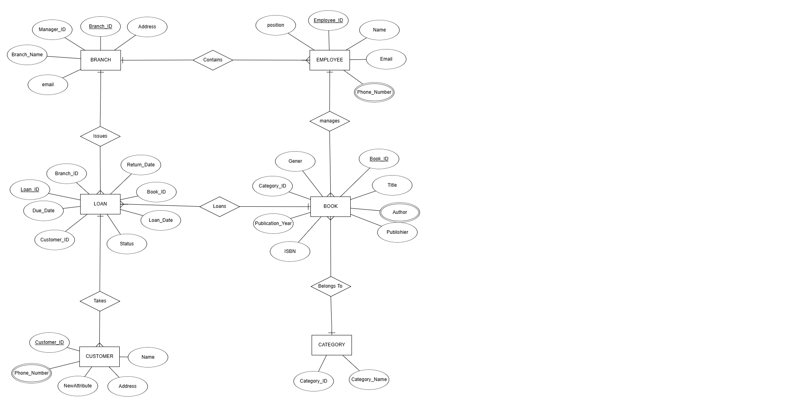

Mapping The ERD to Relational tables
Relational tables: are the core structures in a relational database that store data in a tabular format. Each table represents an entity or a relationship, with rows corresponding to records (or instances) and columns corresponding to attributes (or fields).
Relational tables follow the principles of the Relational Model, as introduced by E.F. Codd, which emphasizes organizing data into well-structured tables and maintaining relationships between them.

Characteristics of Relational Tables
- Rows (Records):
  - Each row in a table represents a single instance of the entity.
  - Example: A row in a "Student" table represents one student.
- Columns (Attributes):
  - Each column represents an attribute or property of the entity.
  - Example: Columns like StudentID, Name, and Age in the "Student" table.
- Primary Key (PK):
  - A column (or combination of columns) that uniquely identifies each row in the table.
  - Example: StudentID could be a primary key in the "Student" table.
- Foreign Key (FK):
  - A column that establishes a relationship between tables by referencing the primary key of another table.
  - Example: A CourseID in an "Enrollment" table might reference the CourseID in a "Course" table.
- Domain Integrity:
  - Each column has a defined data type (e.g., integer, string, date) and may have constraints like NOT NULL, UNIQUE, or DEFAULT.
- Relationships Between Tables:
  - Tables are linked using primary and foreign keys to represent relationships (e.g., one-to-one, one-to-many, many-to-many).

Advantages of Relational Tables
- Data Integrity:
  - Enforced by constraints like primary keys, foreign keys, and domain constraints.
- Scalability:
  - Can handle large amounts of data efficiently with proper indexing and normalization.
- Flexibility:
  - Supports queries and operations through SQL (Structured Query Language).

- Relationship Representation:
  - Easy to model real-world relationships using keys.
- Data Independence:
  - Logical data structure is separate from physical storage.
RELATIONAL TABLE MODEL
1, Book
Attribute | Book_ID | Title | Author | ISBN | Publisher | Publication_Year | Genre | Category_ID
Data Type | INT | VARCHAR  (255) | VARCHAR  (255) | VARCHAR  (255) | VARCHAR  (255) | YEAR | VARCHAR  (255) | INT
2.Customer
Attribute_name | Customer_ID | Name | Address | Phone_no | Email
Data Type | INT | VARCHAR(255) | TEXT | VARCHAR(15) | VARCAHAR(255)
3.Branch
Attribute_Name | Branch_ID | Branch_Name | Branch_Address | Branch_Email | Branch_Manager
Data Type | INT | VARCHAR(255) | TEXT | VARCHAR(250) | VARCHAR(255)
4,Employee
Attribute_Name | Employee_ID | Name | Email | Phone_no | Position
Data Type | INT | VARCHAR(255) | VARCHAR(255) | VARCHAR(15) | VARCHAR(100)
5, LOAN
Attribute_Name | Loan_ID | Loan_Date | Book_ID | Status | Return_Date | Due_Date | Customer_ID
Data Type | INT | DATE | INT | ENUM(‘Active’  ;Returned  ’,’overdue’) | DATE | DATE | INT

6, CATEGORY
Attribute | Category_ID | Category_Name
Data Type | INT | VARCHAR(50)

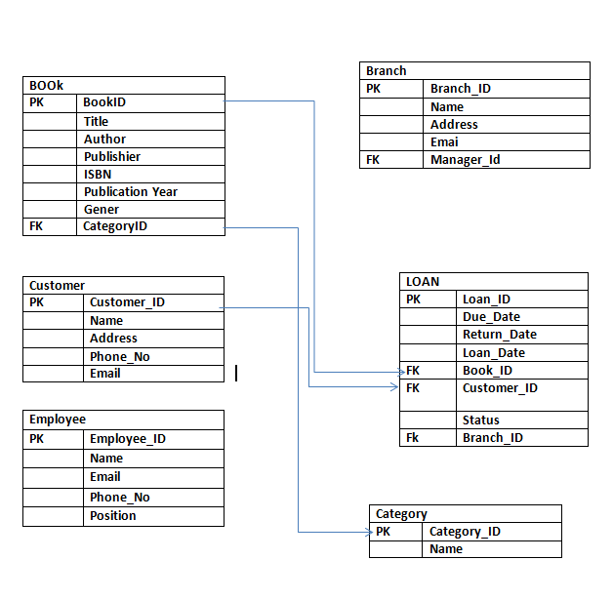

2.6 NORMALIZATION
Normalization : is the process of organizing data in a database into tables and
columns to minimize redundancy and dependency. The primary goal is to divide
large tables into smaller, related tables and link them using relationships. This
process involves applying a series of rules called normal forms, each of which
addresses specific types of redundancy and anomalies.

The most commonly used normal forms are:

1. First Normal Form (1NF): Ensures that the table has a primary key and
that all columns contain atomic (indivisible) values.

2. Second Normal Form (2NF): Builds on 1NF by ensuring that all non-key
attributes are fully dependent on the primary key.

3, Third Normal Form (3NF): Builds on 2NF by ensuring that all non-key
attributes are not only fully dependent on the primary key but also
independent of each other.

Importance of Normalization

Normalization offers several benefits, including:

1. Data Integrity: By eliminating redundancy, normalization ensures that data
is consistent and accurate. For example, in a library management system,
information about a book's author should be stored in one place, reducing
the risk of discrepancies.

2. Efficient Data Retrieval: Normalized databases are structured in a way that
makes querying more efficient. This is crucial for a library management
system where quick access to information about books, patrons, and loans is
essential.

3. Reduced Data Redundancy: Normalization minimizes duplicate data,
which saves storage space and reduces the likelihood of data anomalies. For
instance, storing a patron's contact information in one table prevents the
need to duplicate this information in multiple places.

4. Simplified Maintenance: With a normalized database, updates and
deletions are easier to manage. Changes to data, such as updating a book's
details or a patron's address, can be made in one place without affecting
other parts of the database.
To normalize the data and ensure data integrity, we will apply the normalization rules in stages: 1NF (First Normal Form), 2NF (Second Normal Form), and 3NF (Third Normal Form). Here's a detailed breakdown of the steps:

Step 1: 1st Normal Form (1NF)
1NF ensures that each column contains atomic values, meaning no repeating groups or arrays.

1,Book Table
Book_ID |  | Title | Author |  | ISBN | Publishier | Publication_year | Genre | Category_ID
1 |  | Oromay | Bealu |  | 976-9999-994 | Addis Ababa | 1865 | Novel | 4
2 |  | Tobiya | Sahle |  | 978-9994- 2-001-7 | Mega Pblishier | 1973 | Fiction | 5
3 | Dertogada |  |  | Yesmake | 978-9994-2-003-1 | A.A university | 1945 | Novel | 1
4 | Ye guzo |  |  | Mengistu | 978-9994-2-004-8 | Berhane selam | 1934 | poetry | 2
5 | Lijnet |  |  | Zenbe | 978-9994-3-005-5 | Mega publishinfg | 1845 | science | 3
. Attributes: Book_ID (PK), Title, Author, ISBN, Publisher, Publication_year, Genre,Category_ID
- Normalization Check: No repeating groups found, all attributes are atomic.

2, Customer Table
- Attributes: Customer_ID (PK), Name, Address, Phone_Number, Email
- Normalization Check: No repeating groups found, all attributes are atomic.
Customer_ID | Name |  | Address | Phone_No |  | Email
1 | Biniyam |  | Mizan | 0912345678 |  | bini@email.com
2 | Hamdu |  | Tepi | 0912345679 |  | hamd@email.com
3 | Ethiopia | jimma |  |  | 0987654321 | ethio@email.com
4 | Adane | Hawassa |  |  | 0965784321 | adan@email.com
5 | Belay | Dire dawa |  |  | 0934768591 | bela@email.com

Branch Table
- Attributes: Branch_ID (PK), Branch_Name, Manager_ID, Branch_email, Branch_address
- Normalization Check: No repeating groups found, all attributes are atomic.
Branch_ID | Name | Manager_ID | Branch_Email | Address
001 | Central library | 1212 | Central.lib@email.com | Tepi campus
002 | Computational library | 1212 | Comp.lib@email. Com | Tepi campus
003 | Enginnering library | 1212 | Eng.lib@email.com | Tepi campus
Employee Table
.Attributes: Employee_ID (PK), Name, Position, Phone_No, Email
- Normalization Check: No repeating groups found, all attributes are atomic.
Employee_ID | Name | Position | Phone_No | Email1
1 | Abebe | Manager | 0912121245 | Abe34@email.com
2 | Giyon | Assistant Librarian | 0987654321 | gi21@email.com
3 | Selam | Cataloger | 0978654321 | Selam@email.com
4 | Getachew | Archivist | 0912547680 | getachew@emai.com
5 | Marta | Library Technician | 0990232056 | marta@email .com

Category Table
- Attributes: Category_ID (PK), Category_Name
- Normalization Check: No repeating groups found, all attributes are atomic.
Category_ID | Category_Name
1 | Fiction
2 | Science
3 | Non-Fiction
4 | History
5 | Biography

Loan Table
- Attributes: Loan_ID (PK), Book_ID (FK), Customer_ID (FK), Loan_Date, Due_Date, Return_Date, Status
- Normalization Check: No repeating groups found, all attributes are atomic.
Loan_ID | Book_ID | Customer_ID |  | Loan_Date |  | Due_Date | Return_Date | Status |  | Branch_ID
1 | 1 | 1 |  | 2018-01-15 |  | 2018-02-15 | NULL | Active |  | 1
2 | 2 | 2 |  | 2018-02-10 |  | 2018-03-10 | 2017-01-25 | Returned |  | 2
3 | 3 |  | 3 | 2018-03-11 | 2018-03-15 |  | 2017-02-24 |  | completed |  | 3
4 | 4 |  | 4 | 2018-04-12 | 2018-04-12 |  | NULL |  | active |  | 4
5 | 5 |  | 5 | 2018-05-13 | 2018-04-16 |  | NULL |  | active |  | 5
Conclusion for 1NF: All tables are already in 1NF.
Step 2: 2nd Normal Form (2NF)
2NF requires that the table is in 1NF and that all non-key attributes are fully functionally dependent on the primary key (no partial dependencies).

Book Table
- Primary Key: Book_ID
- Non-key Attributes: Title, Author, ISBN, Publisher, Publication_year, Genre,Category_ID
- All non-key attributes depend solely on the Book_ID, which is the primary key. No partial dependencies are present.

Customer Table
- Primary Key: Customer_ID
- Non-key Attributes: Name, Address, Phone_Number, Email
- All non-key attributes depend solely on the Customer_ID, which is the primary key. No partial dependencies are present.

Branch Table
- Primary Key: Branch_ID
- Non-key Attributes: Branch_Name, Manager_ID, Branch_email, Branch_address
- All non-key attributes depend solely on the Branch_ID, which is the primary key. No partial dependencies are present.

Employee Table
- Primary Key: Employee_ID
- Non-key Attributes: Name, Position, Phone_No, Email
- All non-key attributes depend solely on the Employee_ID, which is the primary key. No partial dependencies are present.

Category Table
- Primary Key: Category_ID
- Non-key Attributes: Category_Name
- All non-key attributes depend solely on the Category_ID, which is the primary key. No partial dependencies are present.

Loan Table
- Primary Key: Loan_ID
- Non-key Attributes: Book_ID, Customer_ID, Loan_Date, Due_Date, Return_Date, Status,Branch_ID
- Dependencies:
  - Book_ID and Customer_ID are foreign keys, and all non-key attributes depend on Loan_ID.
  - There are no partial dependencies because the Loan_ID is the primary key.
Conclusion for 2NF: All tables are in 2NF.

Step 3: 3rd Normal Form (3NF)
3NF requires that the table is in 2NF and that there are no transitive dependencies (non-key attributes depending on other non-key attributes).

Book Table
- Primary Key: Book_ID
- Non-key Attributes: Title, Author, ISBN, Publisher, Publication_year, Genre,Category_ID
- Transitive Dependency Check: No non-key attributes depend on other non-key attributes, so this table is in 3NF.

Customer Table
- Primary Key: Customer_ID
- Non-key Attributes: Name, Address, Phone_Number, Email
- Transitive Dependency Check: No non-key attributes depend on other non-key attributes, so this table is in 3NF.

Branch Table
- Primary Key: Branch_ID
- Non-key Attributes: Branch_Name, Manager_ID, Branch_email, Branch_address
- Transitive Dependency Check: No non-key attributes depend on other non-key attributes, so this table is in 3NF.

Employee Table
- Primary Key: Employee_ID
- Non-key Attributes: Name, Position, Phone_No, Email
- Transitive Dependency Check: No non-key attributes depend on other non-key attributes, so this table is in 3NF.
- Phone_No depends on Employee_ID.
- Email1 also depends on Employee_ID.
- Position depends on Employee_ID as well.
There are no non-key attributes that depend on other non-key attributes. So, this table is already in 3NF.

Category Table
- Primary Key: Category_ID
- Non-key Attributes: Category_Name
- Transitive Dependency Check: No non-key attributes depend on other non-key attributes, so this table is in 3NF.

Loan Table
- Primary Key: Loan_ID
- Non-key Attributes: Book_ID, Customer_ID, Loan_Date, Due_Date, Return_Date, Status,Branch_ID
- Transitive Dependency Check: All non-key attributes depend directly on Loan_ID, and no transitive dependencies are present.
Conclusion for 3NF: All tables are in 3NF.

1,Book Table (3NF):

Book_ID | Title |  | Author | ISBN |  | Publisher |  | Publication_Year | Genre
1 | Oromay |  | Bealu | 976-9999-994 |  | Addis Ababa |  | 1865 | Novel
2 | Tobiya |  | Sahle | 978-9994-2-001-7 |  | Mega Publisher |  | 1973 | Fiction
3 | Dertogada |  | Yesmake | 978-9994-2003-1 |  | A.A University |  | 1945 | Novel
4 | Ye guzo |  | Mengistu | 978-9994-2004-8 |  | Berhane Selam |  | 1934 | Poetry
5 | Lijnet |  | Zenbe | 978-9994-3005-5 |  | Mega Publishing |  | 1845 | Science

2,Category Table:

Category_ID | Category_Name
1 | Novel
2 | Poetry
3 | Science
4 | Fiction
5 | Fiction

3NF Removed transitive dependency by splitting Category_ID into a Category Table.

2, Customer Table
Customer_ID | Name | Address | Phone_No | Email
1 | Mesfin | Mizan | 0912345678 | mes@email.com
2 | Kebede | Tepi | 0912345679 | kebe@email.com
3 | Blen | Jimma | 0987654321 | blen@email.com
4 | Samuel | Hawassa | 0965784321 | Samuel@email.com
5 | Abebe | Dire dawa | 0934768591 | abebe@email.com
3, Branch Table
Branch_ID | Name | Manager_ID | Branch_Email | Address
001 | Central library | 1212 | Central.lib@email.com | Tepi campus
002 | Computational library | 1212 | Comp.lib@email. Com | Tepi campus
003 | Enginnering library | 1212 | Eng.lib@email.com | Tepi campus
4,Employee Table
Employee_ID | Name | Position | Phone_No | Email1
1 | Abebe | Manager | 0912121245 | Abe34@email.com
2 | Giyon | Assistant Librarian | 0987654321 | gi21@email.com
3 | Selam | Cataloger | 0978654321 | Selam@email.com
4 | Getachew | Archivist | 0912547680 | getachew@emai.com
5 | Marta | Library Technician | 0990232056 | marta@email .com
5, category Table
Category_ID | Category_Name
1 | Fiction
2 | Science
3 | Non-Fiction
4 | History
5 | Biography

6, Loan Table
Loan_ID | Book_ID | Customer_ID |  | Loan_Date |  | Due_Date | Return_Date | Status |  | Branch_ID
1 | 1 | 1 |  | 2018-01-15 |  | 2018-02-15 | NULL | Active |  | 1
2 | 2 | 2 |  | 2018-02-10 |  | 2018-03-10 | 2018-01-25 | Returned |  | 2
3 | 3 |  | 3 | 2018-03-11 | 2018-03-15 |  | 2018-02-24 |  | completed |  | 3
4 | 4 |  | 4 | 2018-04-12 | 2018-04-12 |  | NULL |  | active |  | 4
5 | 5 |  | 5 | 2018-05-13 | 2018-04-16 |  | NULL |  | active |  | 5

Draw an Enhanced entity relationship Diagram(EERD) and map it.
An Enhanced Entity-Relationship Diagram (EERD) is an extension of the basic Entity-Relationship Diagram (ERD) that includes additional concepts to better represent complex relationships and data models. While a basic ERD focuses on entities, attributes, and relationships, an EERD adds more advanced features to make the diagram more expressive and capable of handling real-world data complexities.

1. Generalization
- Definition: It is a bottom-up process where two or more lower-level entities with similar characteristics are grouped into a higher-level generalized entity.
- Purpose: To abstract common properties from multiple entities into a single generalized entity.
- Representation: Shown as a triangle connecting the lower-level entities to the generalized higher-level entity.

2. Specialization
- Definition: It is a top-down process where a higher-level entity is divided into two or more specialized lower-level entities based on some distinguishing characteristics.
- Purpose: To define subtypes or specific roles of an entity.
- Representation: Similar to generalization but works in the opposite direction, with a triangle pointing to the higher-level entity and connected to specialized lower-level entities.

3. Aggregation
- Definition: It is a higher-level abstraction where a relationship between entities is treated as a single entity.
- Purpose: To model a "whole-part" or "has-a" relationship between entities and represent a more complex relationship.
- Representation: Represented as a diamond for the relationship, enclosed by a rectangle to form the aggregated entity.

Visual Summary
- Generalization: Combine Car, Truck, and Motorcycle into a generalized Vehicle.
- Specialization: Divide Employee into specific types like Manager and Technician.
- Aggregation: Treat Works On (relationship between Project and Employee) as an entity for further relationships.

EERD Relationships
1. Generalization:
• Person is generalized into Employee and Manager.
• Employee inherits attributes from Person.
• Manager is a specialized version of Employee and manages a Branch.
Entities and Attributes
1. Person (Generalized Entity)
• Attributes: Person_ID (PK), Name, Position, Phone_No, Email.
2. Employee (Subclass of Person)
• Attributes: Employee_ID (PK), Person_ID(FK from Person), Name , Position.
• Relationships: Managed by Manager (via Person_ID), Works at a Branch.
3. Manager (Subclass of Employee)
﻿﻿Attributes: Inherited from Employee (Employee_ID, Name, Position, etc.)
﻿﻿Relationships: Manages Branch (via Manager_ID, FK to Branch)

Relationships and Inheritance Recap:
- Person is the parent entity.
  - Employee and Manager inherit attributes from Person.
  - Manager is a type of Employee and also has the responsibility of managing a Branch.
  - Employee works at a branch and is managed by a Manager.
  - A Manager manages a branch and may also manage other employees

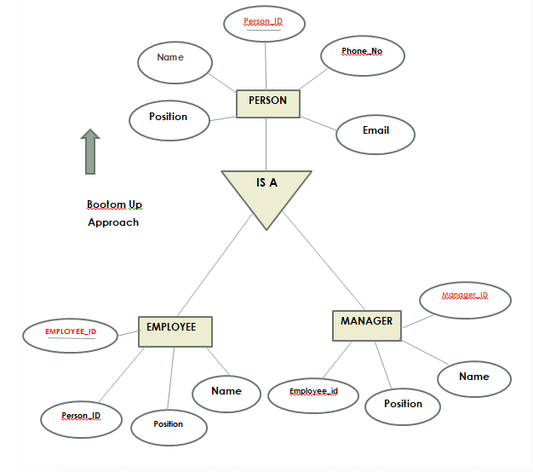 2, SPECIALIZATION
Customer (Specialized into Regular and
Premium Customers) Bootom up Approach
Attributes: Customer_ID (PK), Name, Address, Phone_Number, Email
Relationships: Has many Loans, can borrow books.
. Regular Customer (Subclass of Customer)
Attributes: Inherited from Customer.
Relationships: Can borrow books, no special privileges.
Premium Customer (Subclass of Customer)
Attributes: Inherited from Customer, plus special attributes (e.g., Membership_Card).
Relationships: Can borrow books, special privileges (e.g., discounts).

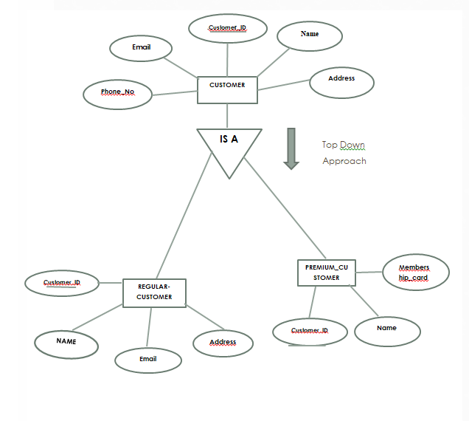
AGGREGATION
Aggregation:
﻿﻿A Loan links a Book to a Customer through a loan transaction and to a Branch.Loan is an aggregation between Book, Customer, and Branch. This means that Loan involves the following: Loan has a relationship with Book, Customer, and Branch.This relationship is part of the Loan transaction, making Loan an aggregate of the involved entities.

CHAPTER THREE
IMPLEMENTATION OF SQL QUERIES
Database Implementation This chapter focuses on the practical aspects of implementing the library database design. It includes schema definitions, SQL commands, and a relational diagram. The emphasis is on ensuring that the database supports all operational needs effectively and efficiently. The introduction of database Implementation for library database design database involves creating a structured framework to efficiently manage library operations, including tracking books, patrons, borrowing activities, and administrative tasks. A well designed database ensures data integrity, supports efficient queries, and facilitates seamless library management. The implementation phase involves creating the database using a Database Management System (DBMS) such as SQL. It includes:
  - Schema Definition: Defining tables, fields, and data types.
  - Constraints: Setting primary and foreign keys, and other constraints for data integrity.
  - Data Population: Loading initial data into the database.
  - Query Optimization: Ensuring efficient data retrieval and manipulation through optimized queries. By implementing a well-designed database system, libraries can overcome the challenges of managing and accessing book records, leading to improved operational efficiency and user satisfaction. The system not only automates routine tasks but also provides valuable insights through data analytics, ultimately enhancing the library's service offerings.

1. Database Creation
sql
-- Create database
CREATE DATABASE LibraryDB;
USE LibraryDB;

-- Create Category Table
CREATE TABLE Category (category
_ID INT PRIMARY KEY,
Category_Name VARCHAR(100) NOT NULL
);

-- Create the Book Table
CREATE TABLE Book (
Book_ID INT PRIMARY KEY,
Title VARCHAR(255) NOT NULL,
Author VARCHAR(255) NOT NULL,
ISBN VARCHAR(20) NOT NULL,
Publisher VARCHAR(255),
Publication_year INT,
Genre VARCHAR(100),
Category_ID INT
);

-- Create the Customer Table
CREATE TABLE Customer (
Customer_ID INT PRIMARY KEY,
Name VARCHAR(255),
Address VARCHAR(255),
Phone_Number VARCHAR(15),
Email VARCHAR(100)
);

-- Create the Employee Table
CREATE TABLE Employee (
Employee_ID INT PRIMARY KEY,
Name VARCHAR(50),
Position VARCHAR(100),
Phone_No VARCHAR(15),
Email VARCHAR(100)
);

-- Create the Branch Table
CREATE TABLE Branch (
Branch_ID INT PRIMARY KEY,
Branch_Name VARCHAR(100),
Manager_ID INT,
Branch_email VARCHAR(100),
Branch_address VARCHAR(100)

);

-- Create the Loan Table
CREATE TABLE Loan (
Loan_ID INT PRIMARY KEY,
Book_ID INT,
Customer_ID INT,
Loan_Date DATE,
Due_Date DATE,
Return_Date DATE,
Status VARCHAR(50),
Branch_ID INT,
FOREIGN KEY (Book_ID) REFERENCES Book(Book_ID),
FOREIGN KEY (Customer_ID) REFERENCES Customer(Customer_ID),
FOREIGN KEY (Branch_ID) REFERENCES Branch(Branch_ID)
);
2.--- Data Insertion
INSERT INTO Category (Category_ID, Category_Name) VALUES
(1, 'Fiction'),
(2, 'Non-Fiction'),
(3, 'Science'),
(4, 'History');

INSERT INTO Book (Book_ID, Title, Author, ISBN, Publisher, Publication_year, Genre, Category_ID) VALUES
(1, 'oromay', 'bealu girma', '9780743273565', 'berhane selam', 1983, 'Fiction', 1),
(2, 'dertogada', 'sahle sellassie', '9780140439218', 'mega publishing', 1859, 'novel', 3),
(3, 'fikir eske mekaber', 'haddis alemayehu', '9780678954', 'addis ababa university', 1983, 'novel', 1);

INSERT INTO Customer (Customer_ID, Name, Address, Phone_Number, Email) VALUES
(1, 'mesfin', 'mizan campus', '0912345678', 'mes@email.com'),
(2, 'kebede', 'tepi campus', '0912345679', 'kebe@email.com');

-- Inserting sample data into Employee table
INSERT INTO Employee (Employee_ID, Name, Position, Phone_No, Email) VALUES
(1, 'abebe', 'Manager', '0912121245', 'abe34@email.com'),
(2, 'Giyon', 'Assistant', '0987654321', 'gi21@email.com');

-- Inserting sample data into Branch table
INSERT INTO Branch (Branch_ID, Branch_Name, Manager_ID, Branch_email, Branch_address) VALUES
(1, 'Central Library', 004, 'central.lib@email.com', '123 tepicampus'),
(2, 'computational library',004, 'comp.lib@email.com', '456 tepicampus');

-- Inserting sample data into Loan table
INSERT INTO Loan (Loan_ID, Book_ID, Customer_ID, Loan_Date, Due_Date, Return_Date, Status, Branch_ID) VALUES
(1, 1, 1, '2017-01-15', '2017-02-15', NULL, 'Active', 1),
(2, 2, 2, '2017-01-10', '2017-02-10', '2017-01-25', 'Returned', 2);
3. CRUD Operations
Create Operation
To insert a new book:
sql
INSERT INTO Book (Book_ID, Title, Author, ISBN, Publisher, Publication_year, Genre, Category_ID)
VALUES (4, 'tobiya', 'gebreyesus hailu', '9780061120084', 'addis ababa university', 1949, 'novel', 1);

INSERT INTO Book (Book_ID, Title, Author, ISBN, Publisher, Publication_year, Genre, Category_ID)
VALUES (5,’tikusat', 'tsegaye gebre-medhin', '9780061120084', 'mega publishing', 1949, 'novel', 1);
Read Operation
To retrieve all books with their category names:
sql
SELECT b.Book_ID, b.Title, b.Author, c.Category_Name
FROM Book b
JOIN Category c ON b.Category_ID = c.Category_ID;
Update Operation
To update the status of a loan:
sql
UPDATE Loan
SET Status = 'Returned', Return_Date = '2025-01-25'
WHERE Loan_ID = 1;
Delete Operation
To delete a customer from the system:
sql
DELETE FROM Customer
WHERE Customer_ID = 2;
4. Additional Constraints
For example, if we want to add a constraint to ensure that a loan's Due_Date is after the Loan_Date, we can use a CHECK constraint.
sql
-- Add constraint to Loan table to ensure Due_Date is after Loan_Date
ALTER TABLE Loan
ADD CONSTRAINT chk_due_date CHECK (Due_Date > Loan_Date);
Query to join
SELECT
1.Loan_ID,
b.Title AS Book_Title,
c.Name AS Customer_Name,
c.Address AS Customer_Address,
1.Loan_Date,
1.Due_Date,
1.Return_Date,
1.Status,
br.Branch_Name
FROM Loan 1
JOIN Book b ON 1.Book_ID = b.Book_ID
JOIN Customer c ON l.Customer_ID = c.Customer_ID
JOIN Branch br ON l.Branch_ID = br.Branch_ID;

SELECT
b.Title,
b.Author,
l.Loan_Date,
l.Due_Date,
l.Return_Date
FROM Loan l
JOIN Book b ON l.Book_ID = b.Book_ID
WHERE l.Customer_ID = 1;

Conclusion
The development of the Library Database System has successfully addressed the limitations of traditional manual library management processes. By designing a relational database with efficient normalization and implementing advanced SQL queries, the system ensures the accurate storage, retrieval, and management of library resources. This project highlights the importance of automation in reducing human error, enhancing data integrity, and providing a user-friendly interface for both library staff and patrons.
The comprehensive database design not only improves the operational efficiency of library management but also supports scalability and adaptability to meet future needs. Features like real-time data updates, secure access protocols, and advanced search capabilities contribute to a seamless and efficient library experience. With the integration of modern database technologies, the Library Database System stands as a robust solution for modern libraries, paving the way for enhanced resource accessibility and user satisfaction.

Reference
• "Database System Concepts" by Abraham Silberschatz, Henry F. Korth, and S. Sudarshan.
• "Database Management Systems" by Raghu Ramakrishnan and Johannes Gehrke.
• Chen, W. (2023). Database Design and Implementation
• Codd, E. F. (1990). The Relational Model for Database Management: Version 2. Addison-Wesley.
• Harrington, J. L. (2016). Relational Database Design and Implementation: Clearly Explained (4th ed.). Morgan Kaufmann

